Item Running Balance Issue
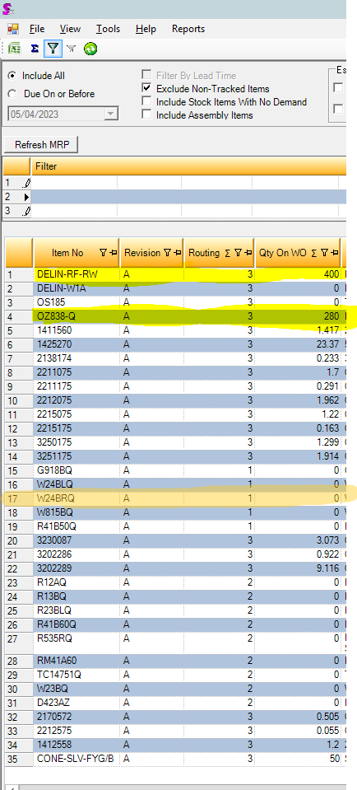
The above screen shot contains a list of items from BNE to be sent to Townsville and what the MRP by Location states as their current qty on WO.

Scenario 1 Example 1
This first scenario shows 2 example items that are stock non make items that I chose from the above snips list.

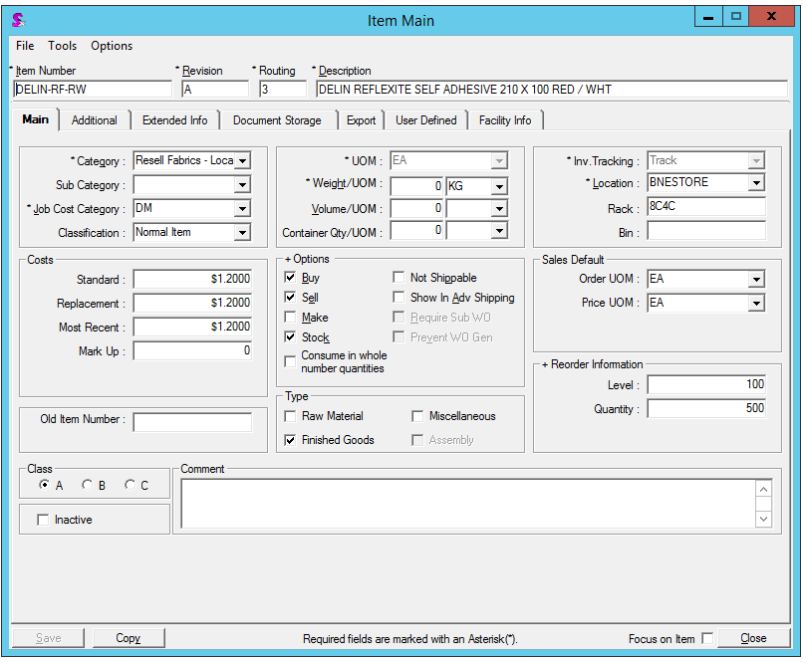
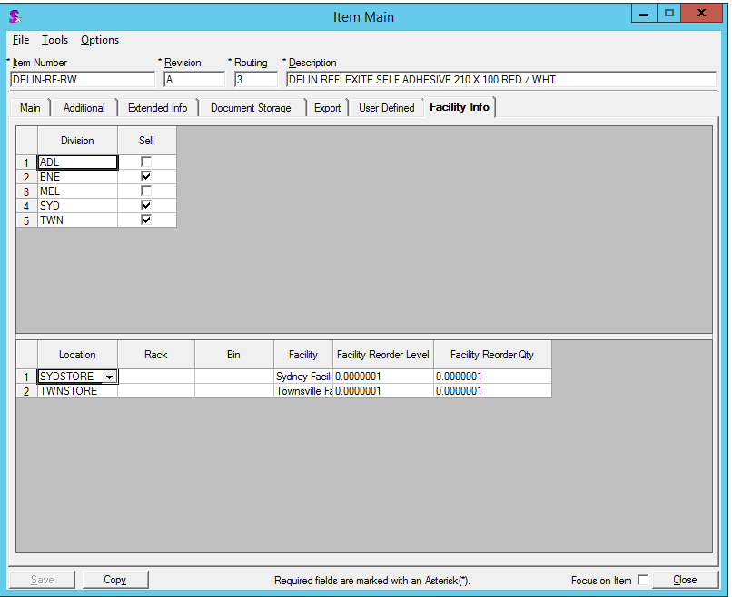
They have their division and facilities all set up as well.
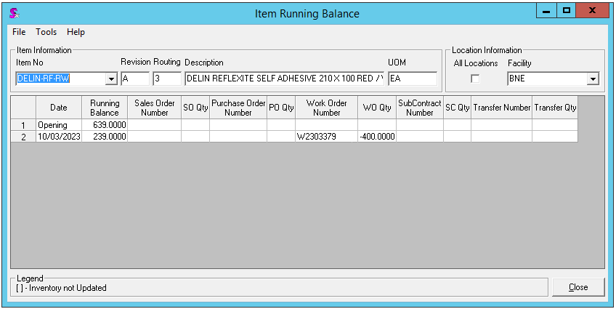
When the Item running balance is viewed, it says this non make item has a work order with a negative 400 qty for the BNE facility.
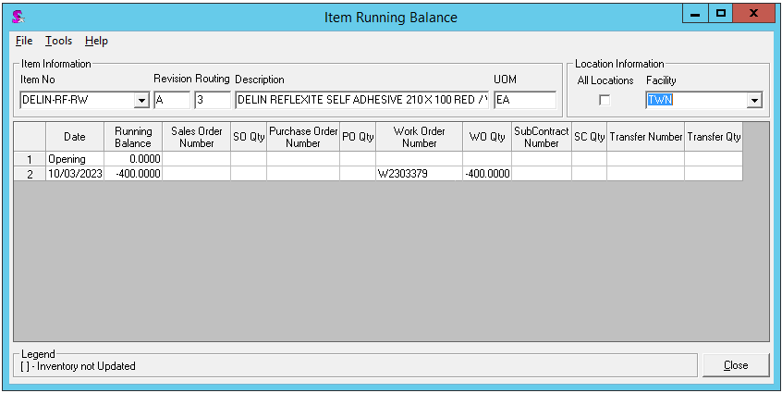
The Item running balance mentions the same work order and qty for TWN facility as well.
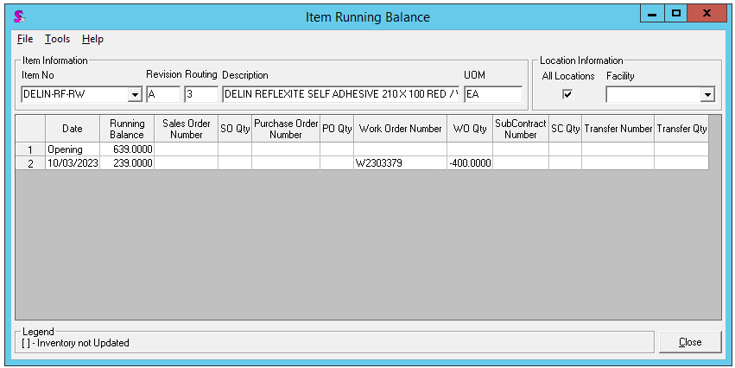
When All locations is ticked, it acts as if there was only one original line.
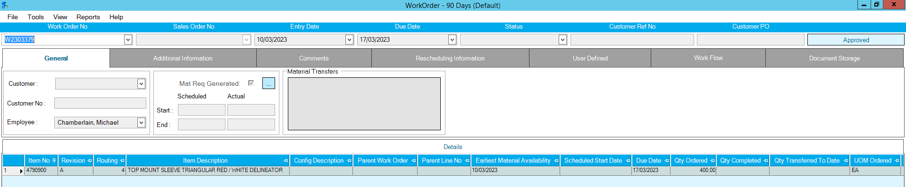
When diving into the relevant work order, there is no line for this particular item in there.

Scenario 1 Example 2
Example 2 follows the same steps as the above example, but showing a different item as the example.
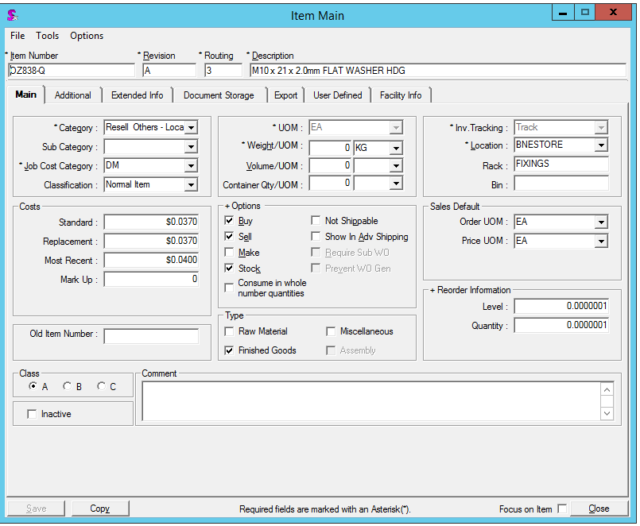
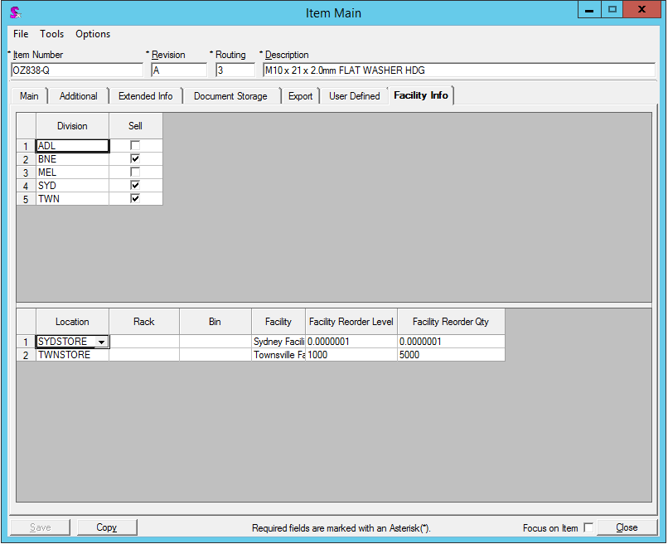
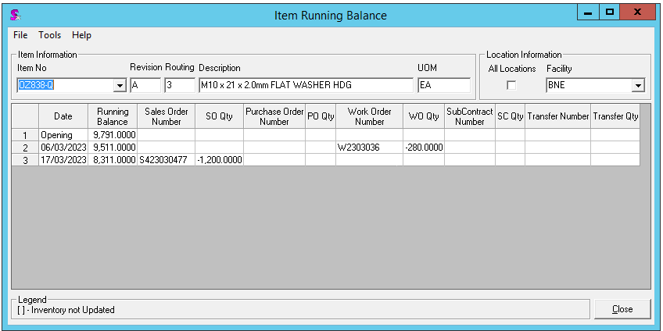
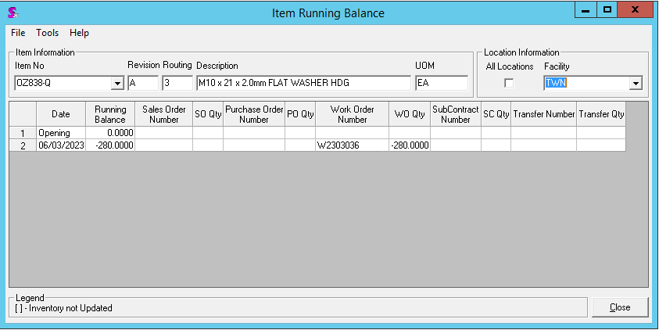
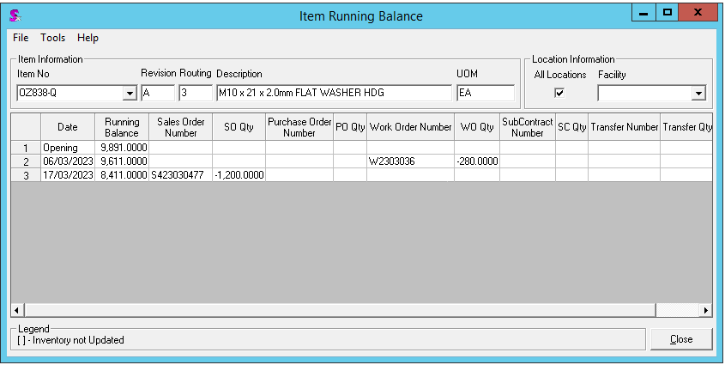
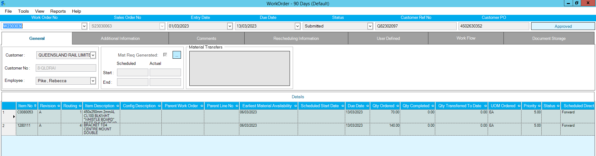
Again this particular item does not exist in the relevant work order.

Scenario 2 Example 1
This scenario portrays a route 1 item that has a work order attached to it for the Townsville facility but as can be seen in the snippet at the very beginning, according to MRP by Location, this item does not have any qty on WO.
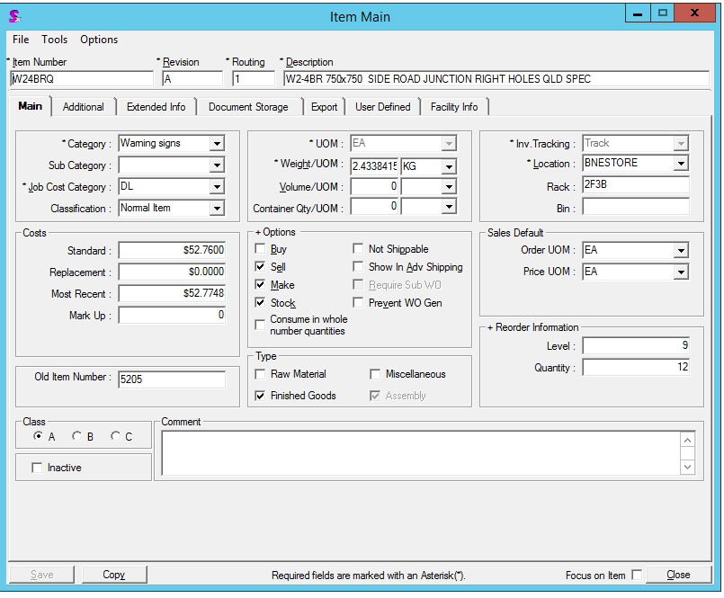
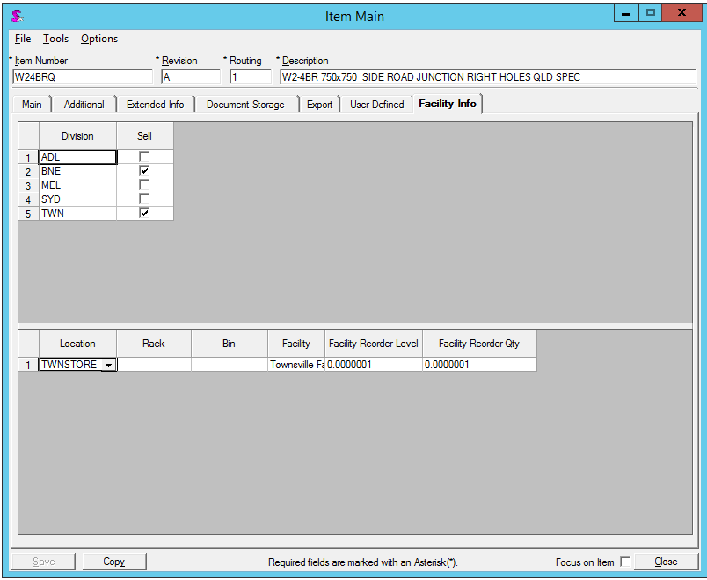
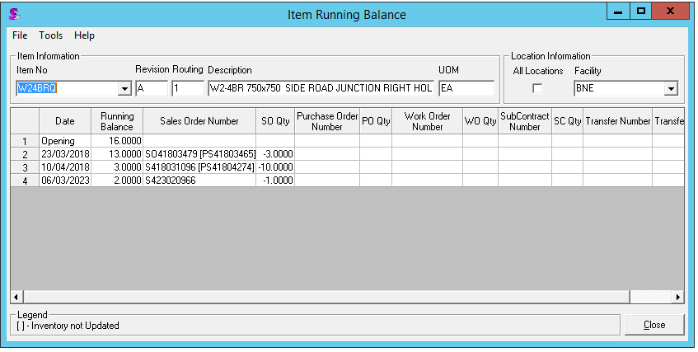
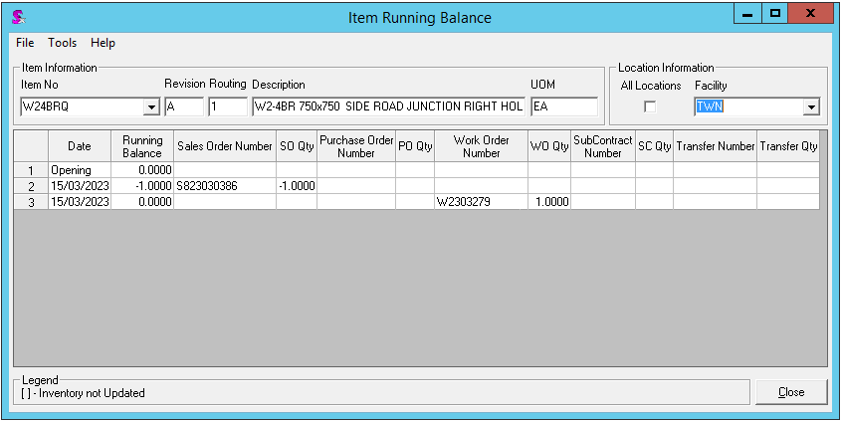
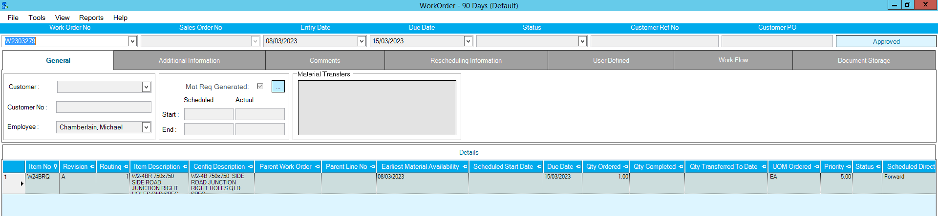
As can be seen, this item indeed does have a Work order for it under the TWN facility and TWNSTORE location, but the MRP by Location shows 0 as qty on WO.

